Giant Ionic Lattice Structures

Strong electrostatic attraction


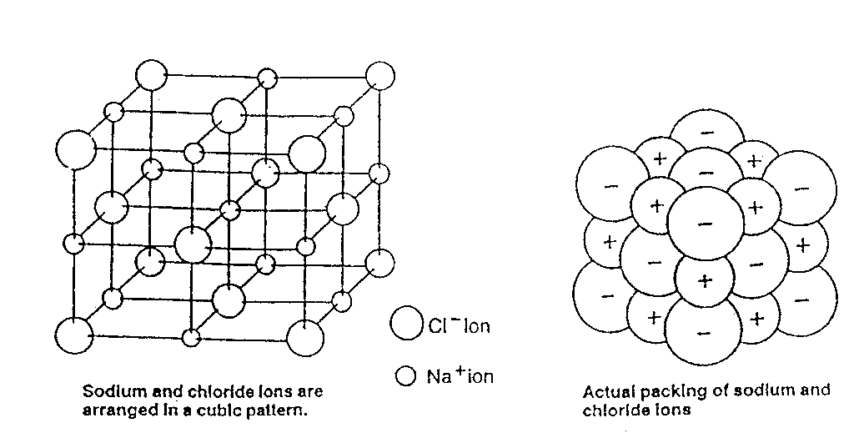

Properties | Reasons
1.  High melting point  (solid at room temperature) | The strong electrostatic attractions (ionic bonds) require a lot of energy to break them.  These bonds are strong since the oppositely charged ions attract each other strongly.
2.  Conducts electricity when molten or aqueous. | (General: for a substance to conduct it must contain mobile, charged particles.)  Ionic compounds contain ions which are attracted to the electrodes and free to move to the electrodes when molten or aqueous.
3.  Soluble in water | The polar water molecules are attracted to the charged ions and this supplies the energy to break up the giant lattice. – see below
